Downloading, Extracting and Setting Up the

2025-2026 TDTIMS Workbook & Processor

***Please contact TIMS Support Staff at NCSU-ITRE or UNC Charlotte if you have questions or hiccups with completing any of the steps throughout the entire TDTIMS Submission process.***

Due to county-level restrictions accessing some LEA TIMS Servers, each LEA will need to download the TDTIMS Workbook and TDTIMS Processor for the 2025-2026 School Year. TIMS Support Staff emailed the Primary TIMS Coordinator from each LEA and provided a link to a Google Drive containing the files needed for Submitting TDTIMS. If you did not receive the email or link, please contact your TIMS Support Staff at NCSU-ITRE or UNC Charlotte.

Below are the steps and instructions for the files inside the 2025-2026 TDTIMS Google Drive.

**1) Download Files from the Google Drive**

* On the TIMS Server, log in to your School System Email and Follow the link provided by TIMS Support Staff to open the 2025-2026 TDTIMS folder.
* Highlight both the tdtimsxlsXXX folder and the TDTIMS Processor
* Right Click and Choose Download

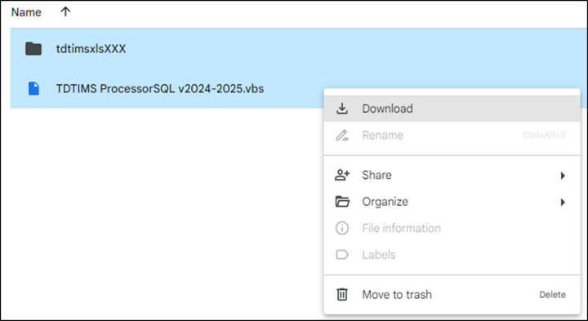

**2) Extract\Unzip the Files to the TIMS DM Account Desktop**

* After the download completes, go to the Downloads Folder and extract both items to your DM Account Desktop.
* Double Click the .Zip File, Choose Extract, Identify the DM Desktop folder location and hit Extract.

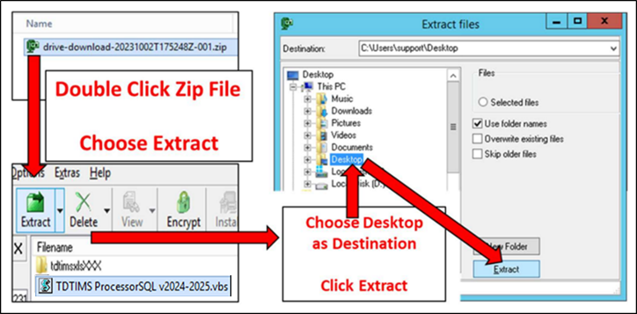

**3) Move the Files to the Root of the C:Drive**

* The next steps are to cut\copy\paste both items from the DM Desktop to the root of the C:\ drive of the TIMS Server.
* Depending on local county-level restrictions, some DM Accounts may not have the proper permissions\credentials to move items to C:\
* When completed, both the tdtimsxlsXXX folder and the TDTIMS Processor will be at the root of C:\

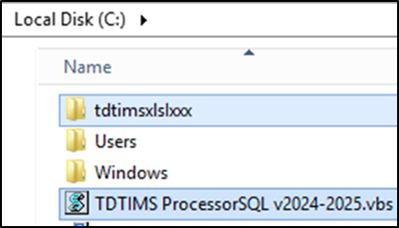

***If you have trouble downloading the files, extracting them to the desktop or copying them to the root of the C:Drive, please contact TIMS Support Staff for assistance in getting everything in place before you begin the 2025-2026 TDTIMS Submission.***