**Importing Student AM\PM Bus Requests into Infinite Campus**

Managing Student Transportation Requests in Infinite Campus

On the Student Transportation Screen in Infinite Campus there are options to Manage Student Transportation Requests for AM and PM Bus Assignments. If used by your school system, School Staff can make changes to individual student requests as new riders ask for bus service and existing bus riders request changes or no longer need a bus assignment. The updated Transportation Codes can then be used by the School Transportation Department to ensure transportation changes are completed within TIMS, the school bus routing system.

General Information about Managing Student Transportation Requests can be found here: <https://www.ncbussafety.org/tims/documents/infinite_campus/3_managing_student_requests.docx>

**\*\* Importing Student AM\PM Bus Requests into Infinite Campus \*\***

School Systems using the student transportation page to communicate bus requests to TIMS will often have the need to complete mass updates and changes for dozens\hundreds of student requests throughout the year.

* Following 10-Day Counts or After Weekly\Monthly Driver Updates
* End of Year Updates or Resetting Codes for the Next School Year
* Import of New Student Bus Requests from Online Registration (OLR) Systems

Using a Spreadsheet, Export from an OLR System or Info from another Data Source; the TIMS Request Import requires a CSV File with correct column headers to successfully update Student Bus Requests through the Infinite Campus Data Import Wizard (DIW). Each student should only have 1 row of data and the file must contain all five columns with correct headers for Student ID, AM Code, AM Alternate Address, PM Code and PM Alternate Address.

Example CSV File and Column Headers needed for the TIMS Request Import into Campus



* Column A = StudentStateID
* Column B = AM_Code
* Column C = AM_AltAddr
* Column D = PM_Code
* Column E = PM_AltAddr

**AM Code and PM Code Information**

For the AM Code and PM Code Columns, Infinite Campus will only accept a Single Letter Code that corresponds to one of the options under the Transportation Code AM and PM Dropdown Menus.

Y = Yes – Home Address

N = No – Non-Rider

A = Alternate Address

E = Special Needs

T = Contract Transportation

W = Walk\No Transport Zone

B = Bicycle Rider

C = Car Rider

D = Daycare Transportation

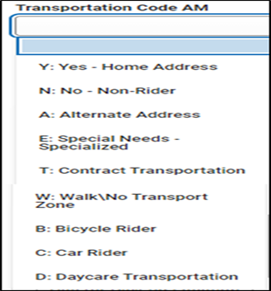

**AM and PM Alternate Address Information**

If your school system allows Bus Stop Requests to\from an Alternate (Non-Home) Address such as a Relative’s House, an Afterschool Program, Boys and Girls Club, etc.; the TIMS Bus Request Import also provides the ability to import new Alternate Addresses* as well as Blank\Purge any existing Alternate Addresses that need removed from the Request Screen.

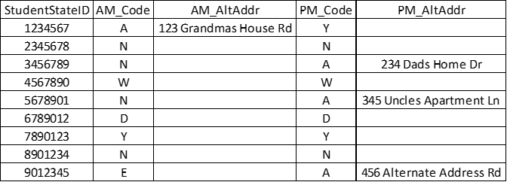

In the example above, there would be an Alternate AM Address imported for one student and an Alternate PM Address imported for three students. Because the other Alternate Addresses are all empty, the other students in this file would have any existing alternate addresses deleted and removed from student transportation requests.

***\*Alternate AM\PM Addresses do not require the entry of city, state and zip code. Alternate AM\PM Addresses should be entered so they match the TIMS Location needed for transportation assignments.***

The final CSV File used for import does not have to contain records for all students. The TIMS Request Import will only update transportation requests for students within the CSV File. Requests for students not in the file will remain untouched and exactly the same following the import.

When finished developing and formatting the Student Request Spreadsheet, Save the File as a CSV.

Then go to the Data Import Wizard (DIW) within Infinite Campus to begin the Import\Update\Backload of TIMS Bus Request Data.

**How to Import\Backload TIMS Request Information into Infinite Campus.**

Before Beginning the Import\Backload of TIMS Data into Campus, please complete the development and formatting of the spreadsheet\CSV file to meet Campus Import Specifications.

1. Log into Infinite Campus via NCEdCloud
2. From the Main Menu on the Left, Scroll to the Bottom and Choose System Settings
3. Then Choose Data Import Wizard under the Data Utilities Section

**System Settings > Data Utilities > Data Import Wizard**

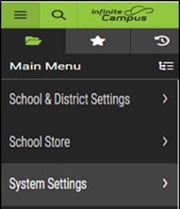 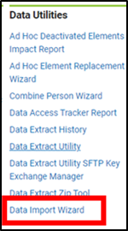

1. Under Import Type – Choose the PSU TIMS REQUEST IMPORT
2. Under Layout – Choose PSU TIMS REQUEST IMPORT if not already selected

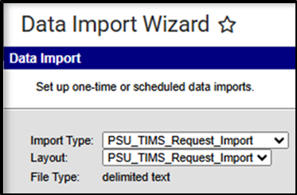

1. Click Choose File and Select the CSV File containing the formatted Bus Request Information to be imported into Campus.
2. Users can then TEST IMPORT prior to the actual update of the Data or proceed directly by clicking the RUN IMPORT button.

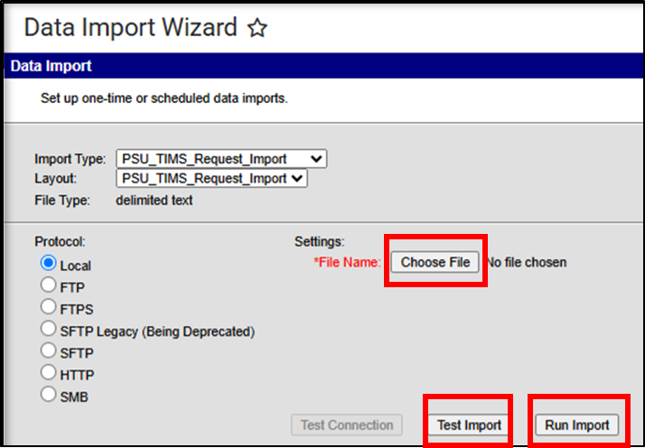

1. When the TEST IMPORT or RUN IMPORT is completed, there will be an Output Log under Import History that can be reviewed. Click the Link under FILE NAME to view this information.

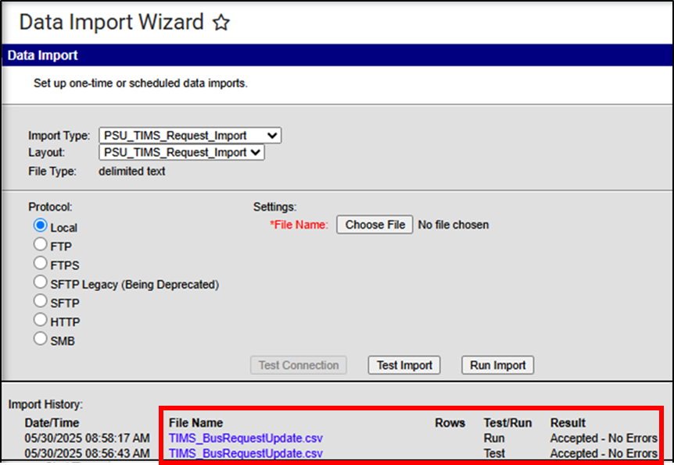

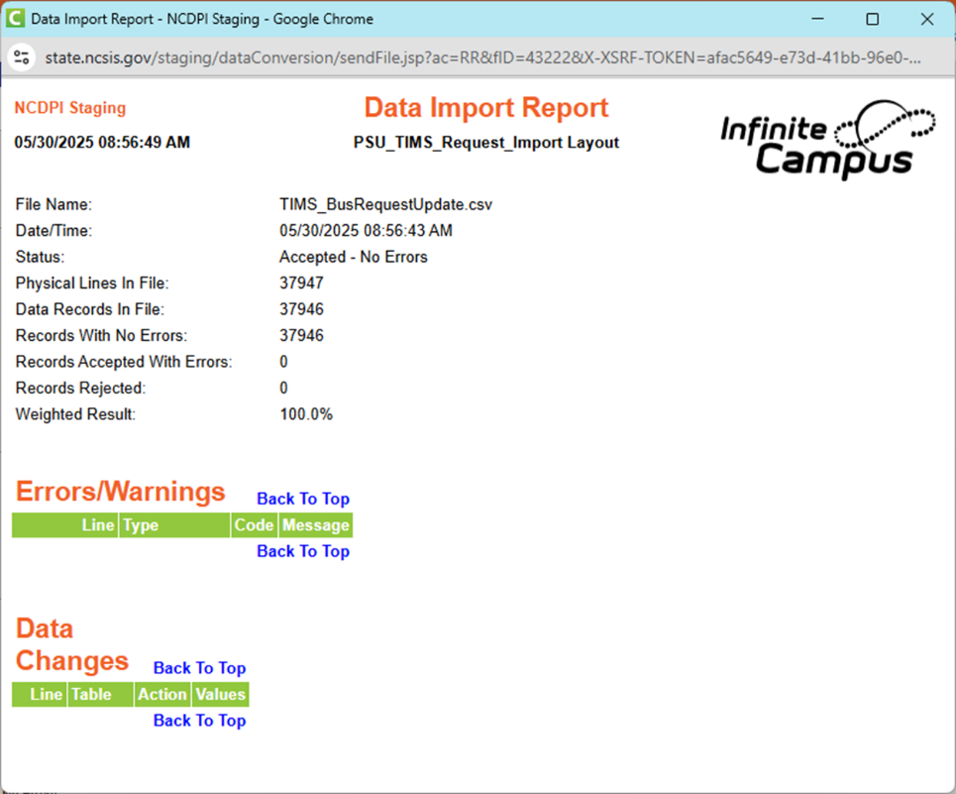

1. If a TEST IMPORT was completed in Step 7, re-select the CSV file and choose RUN IMPORT to perform the actual update to Student Bus Request Information within Campus.