Creating and formatting the TIMS Report for Import of Assigned Student Information into Infinite Campus

Before beginning the back load of TIMS Bus Stop Data into Campus; it is important that TIMS is fully updated. Make sure all student assignments, bus numbers and stop times are correct and as accurate as possible. Do Not Back Load Outdated, Inaccurate, Incorrect or Sloppy TIMS Data into Infinite Campus.

As part of Initial Conversion to Infinite Campus, TIMS Support Staff helped create the report used to Import\Back Load TIMS Data into Campus. If the report was not create or is missing from a TIMS Dataset, please contact TIMS Staff at NCSU-ITRE or the UNC Charlotte Urban Institute.

**Running the TIMS Report for Import into Campus**

1. Open Edulog Reports
2. Go to User Defined Reports > All Student and Transportation
3. Highlight the **TIMS to Campus Backload** Report

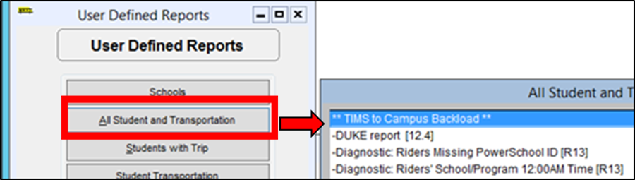

1. Check that the Report is set to Disk File Output
2. Check that the Report Path is Valid
3. Click Run Report to Generate the TIMS to Campus Backload Spreadsheet

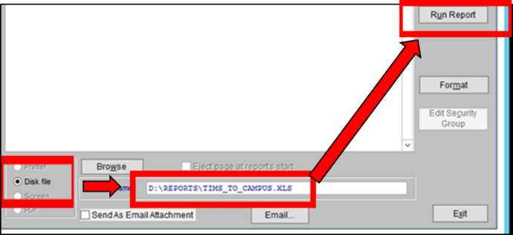

**Formatting the TIMS to Campus Spreadsheet for Import**

1. Open the newly created spreadsheet in Excel
2. Remove Leading Zeroes from the Student ID
   1. Highlight All Student IDs and Convert to Number Format

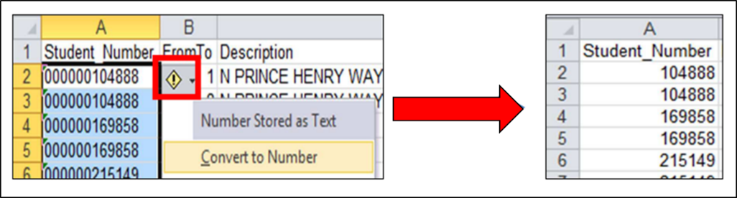

1. Highlight the Column with Run Type - Search\Replace Run Type Values
   1. 1 = To
   2. 2 = From
   3. 3 = To ; If you have Trip 3 Values in TIMS
   4. 4 = From ; If you have Trip 4 Values in TIMS

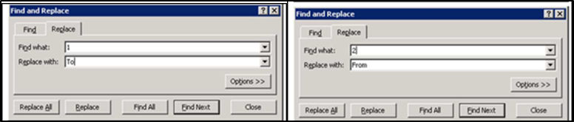

1. Update the Column Headers to Match Infinite Campus Values

Column A = StudentStateID

Column B = RouteName

Column C = RouteTypeCode

Column D = BusNumber

Column E = StopDescription

Column F = StopTime

Column G = SchoolDist

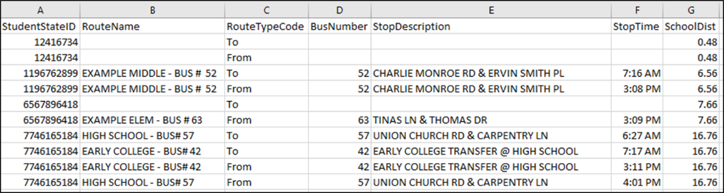

1. After formatting the spreadsheet, Choose File>Save As
2. Switch the File Type to CSV (Comma DELIMITED)
3. Save the Formatted CSV File where you can easily find it on the TIMS Server.

