**Managing Student Transportation Requests in Infinite Campus**

**Accessing the Student Transportation Screen**

1. Log into Infinite Campus via NCEdCloud
2. From the Main Menu on the Left, Choose Student Information and then Transportation
3. Search for a Student by Name or Student ID to view their Transportation Screen.
4. If a Student Record had already been selected, Choose Transportation from the list of Student Pages now on the right side of the screen.

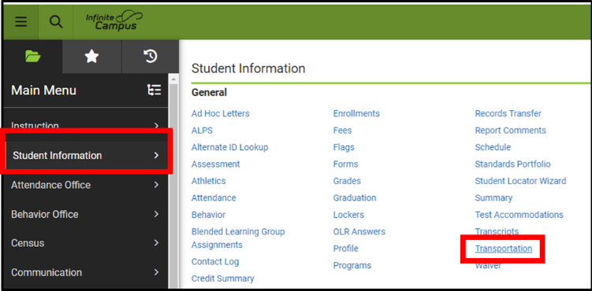 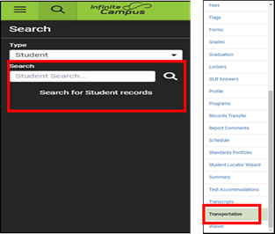

**Understanding the Transportation Screen Layout: Today’s Busing, Routes and Requests Section**

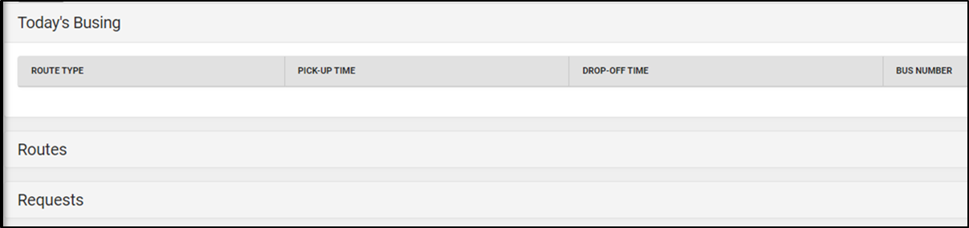

**Today’s Busing**

LEAs that import\backload TIMS Bus Assignment Information will see the most recent data imported into Infinite Campus the top as a Quick Reference for Staff (Stop Time and Bus Number)

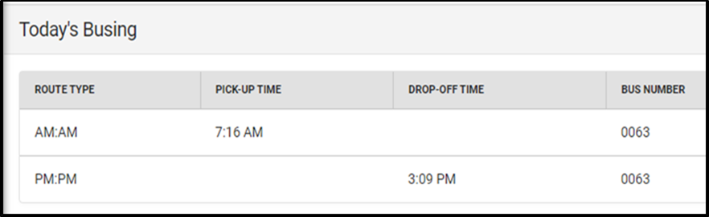

If no information is shown under Today’s Busing, the Student is either not an assigned bus rider within TIMS or no TIMS Data has been imported for this student. There is a separate process and set of Instructions for Importing Student Bus Information into Infinite Campus. Please refer to those instructions found at NCBusSafety.Org

**Routes**

Under Today’s Busing, only the Bus Number and Stop Times are displayed for Quick Reference but additional information is also imported and available to view under the Routes Section.

Open the Routes Section and Click the Edit Button associated with the Assigned AM and\or PM Trips: Stop Location, Run Description, Distance to School, as well as Bus Number and Stop Time are all shown for each student trip.

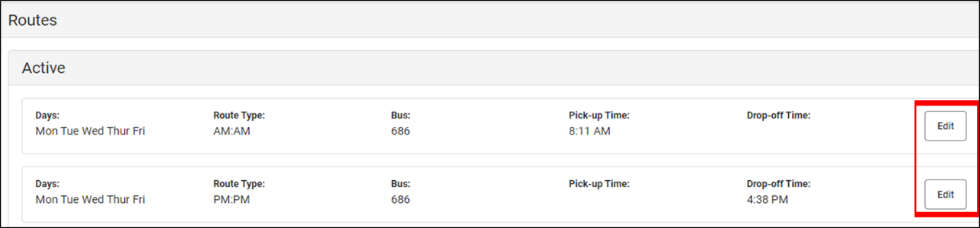

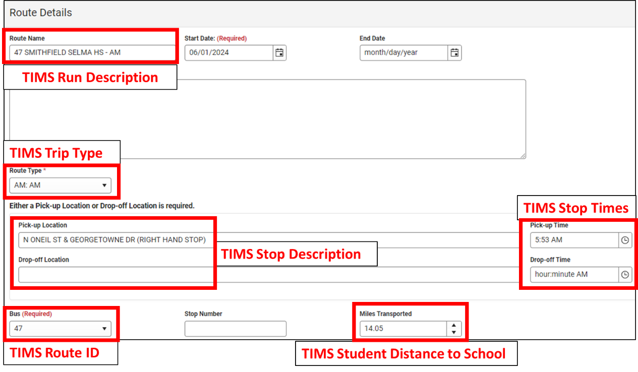

Don’t Not Edit, Change or Delete any information under the Routes Section. This information is managed (deleted, refreshed or updated) through the Import\Backload of TIMS Data into Infinite Campus. Please refer to those instructions found at NCBusSafety.Org

**Requests**

**Understanding Student Bus Stop Requests in Your LEA**

Before discussing the different options for managing student bus requests in Infinite Campus, it is important to understand that each County, Charter and City School System will have established methods for handling student bus stop requests. These methods may or may not involve the use of the Infinite Campus Transportation Screen.

**Please communicate and coordinate with local Transportation Staff to understand the specific methods within your LEA.**

If your LEA is not currently using the SIS Transportation Screen to Manage Bus Stop Requests but are interested in implementing this feature of TIMS & Infinite Campus, please have local Transportation Staff contact TIMS Project Leaders at North Carolina State University or UNC Charlotte. TIMS Support Staff can advise you on the best approach to begin implementing this feature within your LEA.

**Managing AM\PM Bus Stop Requests**

1. Open the Transportation Page for the Student
2. Choose Requests
   1. If No Requests Exist, Choose New to Enter Bus Stop Request Information
   2. If Requests already exist, Choose Edit to the Open Bus Stop Request

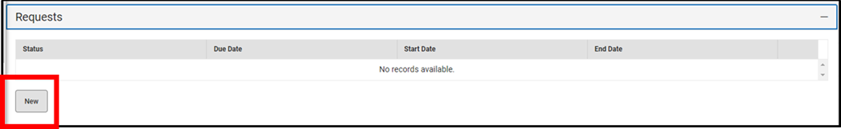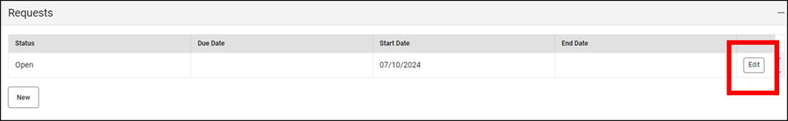

1. Leave the Request Status set to Open
2. Start Date should default to the date of request entry or edit and reflect the Current Bus Request for the student. Do Not Edit this date for Future Requests days, weeks or months ahead of the current date.
3. Comments can be viewed and entered if desired here but they will not Import into TIMS. We suggest not using the Transportation Comments Section of Requests.

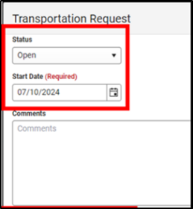

1. The next three fields (Accommodations, Monitor and Lift Required) mostly relate to Special Needs Students and the available selections are the same as they were in PowerSchool. If used by your Transportation Department, these fields should be updated following an IEP Meeting and the Approval for Specialized Student Transportation Requirements.

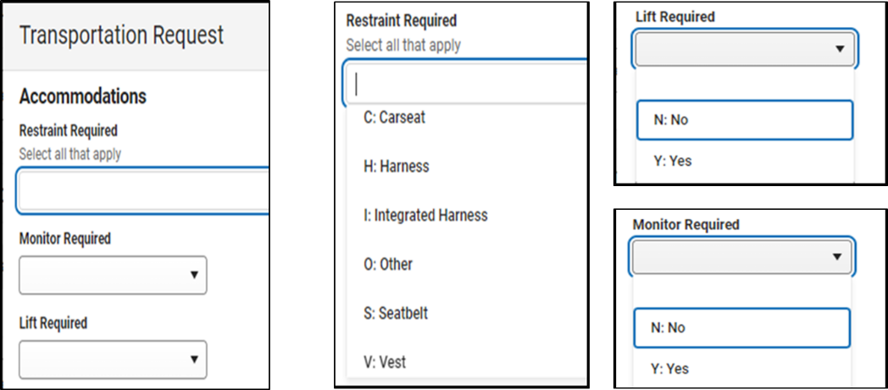

1. The next two fields (Transportation Code AM and Transportation Code PM) relate to all students within the LEA and the available selections are the same as they were in PowerSchool. If used by your Transportation Department, these fields will need managed for each Bus Rider (and possibly all students) within the LEA.

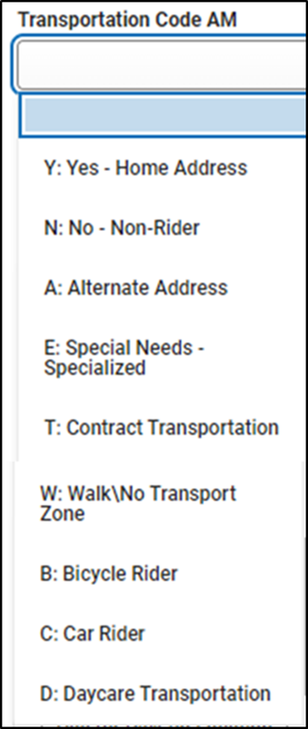

1. The next field (Route Type) must be marked as REQUEST for the Open Transportation Request within Campus. After making the student selections for AM and PM (and\or the Accommodations, Monitor and Lift options), Choose REQUEST under Route Type and Click Save to officially submit the request.

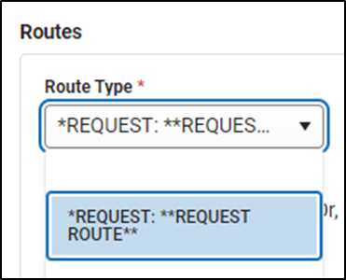 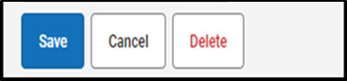

1. Upon downloading the next TIMS Extract from Infinite Campus, the AM\PM Ridership Codes and Special Needs options will all be imported into TIMS and available to help manage bus assignments.

Below is an example Stop Request for a Student to Ride To\From Home for both AM and PM

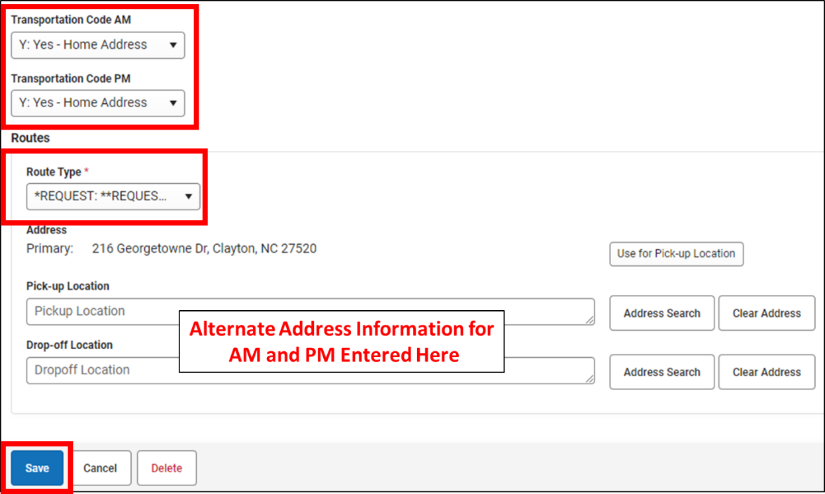

1. Some LEAs also permit student bus requests to an Alternate (non-home) Address with some using only a shared spreadsheet or other means to communicate the alternate address, while others allow Alternate Address Entry onto the SIS Transportation Screen, which is then imported directly into TIMS and more easily used for Student Assignments.

Please consult with your Transportation Department if Alternate Address Requests are allowed in your LEA and how they need to be communicated and managed by School Staff.

If Alternate Addresses are managed and communicated via the SIS Transportation Screen, see the next set of instructions for entering Alternate AM and PM Addresses as part of Student Transportation Requests in Infinite Campus.

**Please communicate and coordinate with local Transportation Staff to understand the specific methods within your LEA.**

**Managing Alternate Address Information for AM\PM Bus Stop Requests**

1. Expand the Requests Tool.
2. Choose Requests
   1. If No Requests Exist, click New to Enter Bus Stop Request Information
   2. If Requests already exist, Choose Edit to Update\Change\Delete the Bus Stop Request

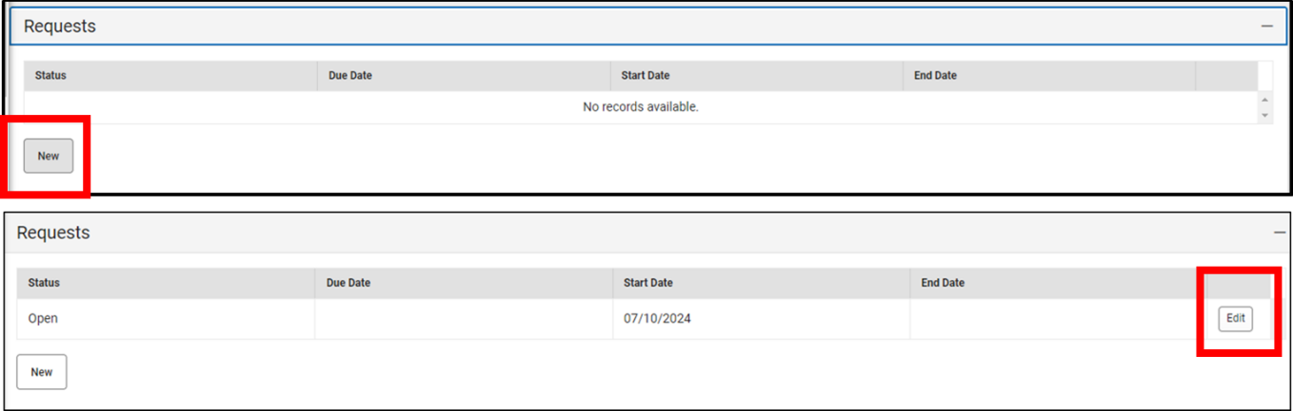

1. Leave the Request Status set to Open
2. Start Date should default to the date of request entry and reflect the Current Bus Request for the student. Do Not Edit this date for Future Requests days, weeks or months ahead of the current date.
3. The next three fields (Accommodations, Monitor and Lift Required) mostly relate to Special Needs Students. If used by your Transportation Department, these fields should be updated following an IEP Meeting and the Approval of Specialized Student Transportation Requirements.
4. The next two fields (Transportation Code AM and Transportation Code PM) relate to all students within the LEA. If used by your Transportation Department, these fields will need managed for each Bus Rider (and possibly all students) within the LEA.
   1. If the student is requesting an Alternate Address for AM or PM, staff should select A:Alternate Address under the drop down menu. This will alert TIMS Staff that transportation is to a non-home address.
5. The next field (Route Type) must be marked as REQUEST for each Transportation Request. After making the student selections for AM and PM (and\or the Accommodations, Monitor and Lift options), Choose REQUEST under Route Type.
6. For an AM Alternate Address, enter the alternate address in the Pick-Up Location Box
   1. TIMS requires only the House Number and Full Street Name of the Alternate Address. Do not enter City, State, Zip Code or Apartment\Lot Numbers in this field. 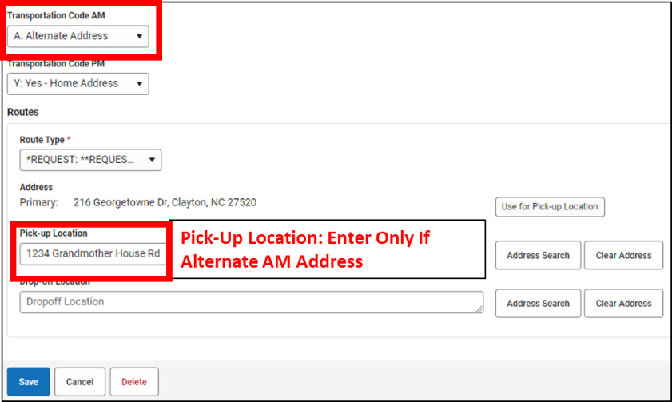
7. For a PM Alternate Address, enter the alternate address in the Drop-Off Location Box
   1. TIMS requires only the House Number and Full Street Name of the Alternate Address. Do not enter City, State, Zip Code or Apartment\Lot Numbers in this field.

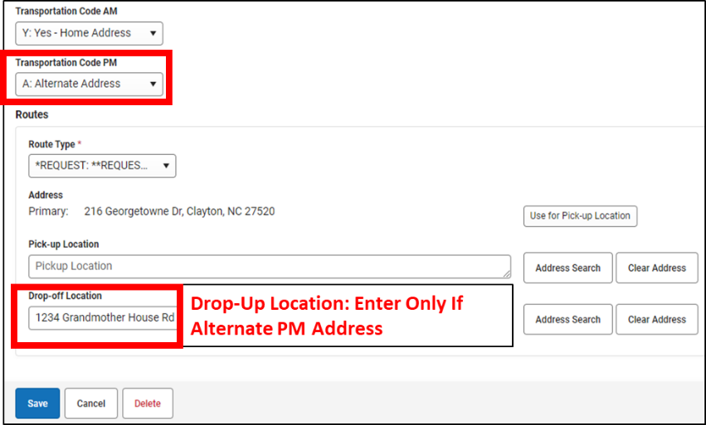

1. Do Not Populate the Pick-Up or Drop-Off Locations with the Students Home Address. Only complete these fields if different from the home address.
2. After Completing Data Entry, Choose SAVE at the bottom of the request screen
3. Upon downloading the next TIMS Extract from Infinite Campus, the AM\PM Ridership Codes, Special Needs options and Alternate AM\PM Locations will all be imported into TIMS and available to help manage bus assignments.

**Please communicate and coordinate with local Transportation Staff to understand the specific methods within your LEA.**