**How to Download of the TIMS Extract from Infinite Campus –**

**\*\*Updated October 2025\*\***

1. Log into Infinite Campus via NCEdCloud
2. From the Main Menu, Choose System Settings
3. Find the Data Utilities Section and Click the Data Extract Utilities link

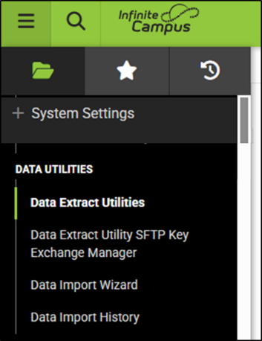 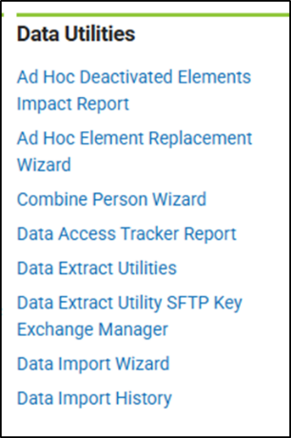

1. The \****NCDPI - TIMS Extract*** should be near the top of the list of Data Extract Utilities
2. Highlight the *NCDPI – TIMS Extract and Choose EDIT from the Actions Menu on the Right

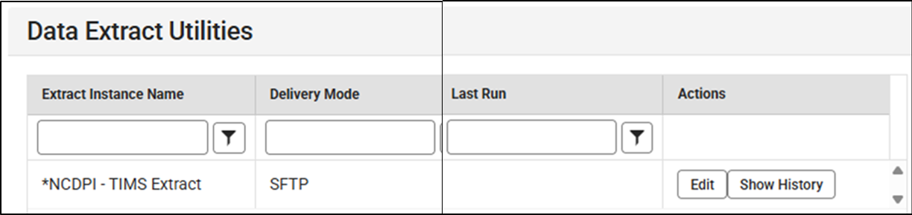

1. On the bottom of the next screen, you can manually download the TIMS Extract (PreStu.csv) by Clicking the TEST EXTRACT button

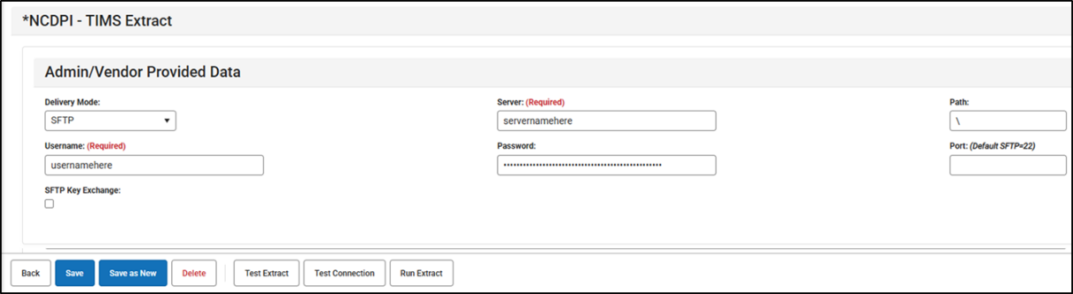

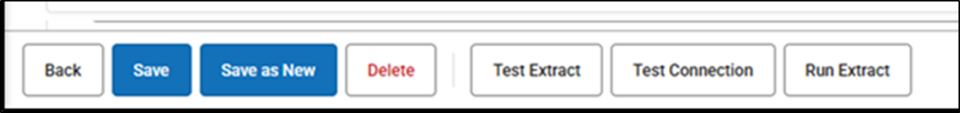

1. Upon Completion, go to your Downloads Folder and look for the latest PreStu.csv file
2. Use the PreStu.csv File to begin the UPSTU Process within TIMS

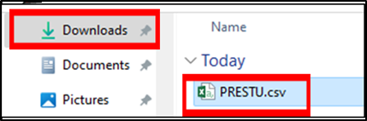

**Scheduling Automated Downloads of the TIMS Extract**

There are options to set up the TIMS Extract to be automatically created and sent to a file folder or shared drive within the local school network as well as to a 3rd Party Vendor or other entity outside the school system. Please consult and work with your Local Campus Coordinator, IT Staff and\or 3rd Party Vendors for help setting up any automated extracts from campus.

There are sections for SFTP Info, Server Names, File Paths and Port Connections as well as a section to include any Dates\Timestamps and to set up the Scheduled Frequency of the Data Extract. Once the settings are in place, Click Test Connection to troubleshoot the File Path Info and Click Run Extract to Begin as Scheduled.

