School Bus Safety Minute Presentation

A Guide for Use with Students on the Bus

Instructions for Bus Drivers

This guide was developed for use by bus drivers in presenting safety information to students. Each topic covered in the guide can be presented in less than a minute and can be printed and handed out to students.

Topics Covered in the Guide:

* Arriving at the Bus Stop
* Waiting for the Bus
* Boarding the Bus
* Conduct on the Bus
* Getting off the Bus
* Danger Zone
* Emergencies
* Bus Evacuation Procedures

North Carolina Department of Public Instruction

Transportation Services

919.807.3570

C:\Users\dmhughes\AppData\Local\Microsoft\Windows\Temporary Internet Files\Content.IE5\FD01AL8M\MC900013196[1].wmfInformation compiled in cooperation with Craven County Schools transportation department and the school bus pedestrian safety task force coordinated by the Center for Urban Affairs and Community Studies at N.C. State University.

**ARRIVING AT THE BUS STOP**

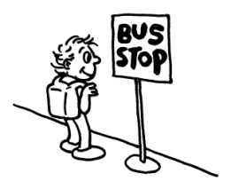**Arrive Early at the Bus Stop**.

* Leave Home early enough to reach the bus stop 5-10 minutes before the bus is scheduled to arrive.

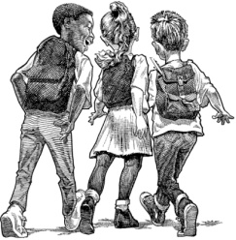**Walk Safely.**

* Walk!! Don’t run.
* If there is a sidewalk, use it!
* Where there is no sidewalk, walk on the LEFT side of the road facing traffic.
* Never walk in the roadway. Walk on the LEFT side of the roadway, staying far away from traffic.

**Crossing Streets Safely.**

* It is best to cross at the corner or at an intersection. This is where drivers expect to see you.
* Use a crosswalk if one is available.
* Pay attention! STOP, LOOK, AND LISTEN before crossing the road.

**WAITING FOR THE BUS**

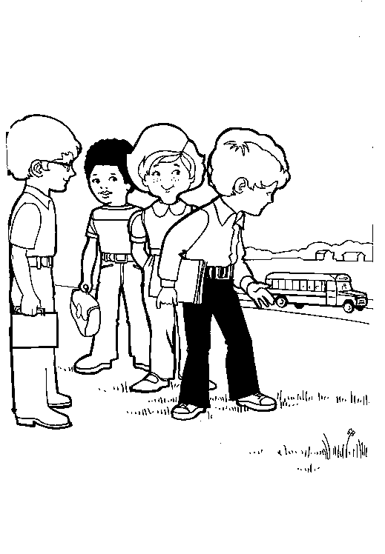

**Wait in a Safe Place.**

* Stay at least 12 feet away from the edge of the street or roadway. (4-5 giant steps)

**Respect Property.**

* C:\Users\dmhughes\AppData\Local\Microsoft\Windows\Temporary Internet Files\Content.IE5\R3R21A7P\MC900053977[1].wmfRESPECT private property.
* Never leave any trash at the bus stop.

**No Horseplay**

* DO NOT run around or play at the bus stop.
* WAIT QUIETLY. Loud noises disturb others near a bus stop.
* Stay out of the street or road while waiting for the bus. Traffic is dangerous.

**BOARDING THE BUS**

**Prior to Bus Stopping**

* Face the direction of the approaching bus, staying at least 12 feet away from the designated stopping location.

**Getting on the Bus**

* WAIT until the bus comes to a complete stop and the front door opens.
* 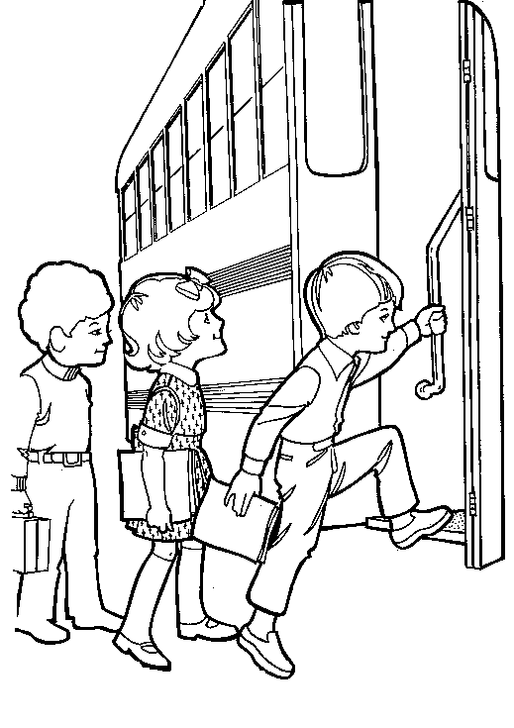Get on the bus in an orderly manner and use the handrail.
* STOP, LOOK, and LISTEN before crossing the street or road.
* MAKE EYE CONTACT with the school bus driver. If you can’t see the driver, the driver can’t see you!
* Get on the bus in an orderly manner and use the handrail.

**CONDUCT ON THE BUS**

**No Disruptive or Distracting Behavior**

* School rules apply at the bus stop and on the bus.
* 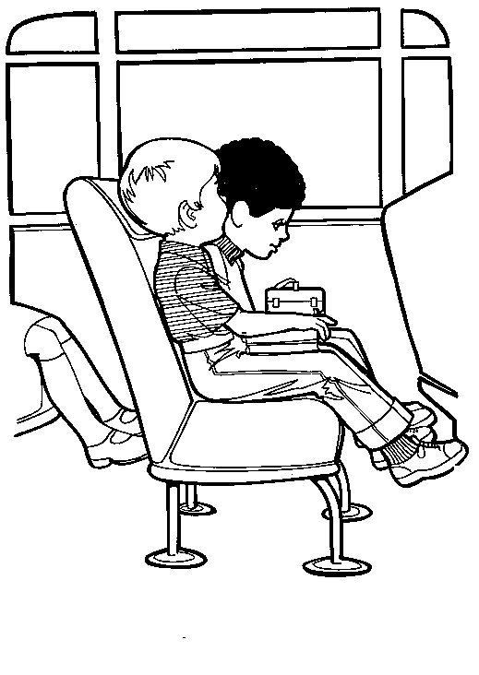Talk Quietly. Do not distract the driver. The driver must concentrate on driving to keep you safe.

**Be Responsible and Respectful.**

* Stay in your seat facing forward at all times.
* 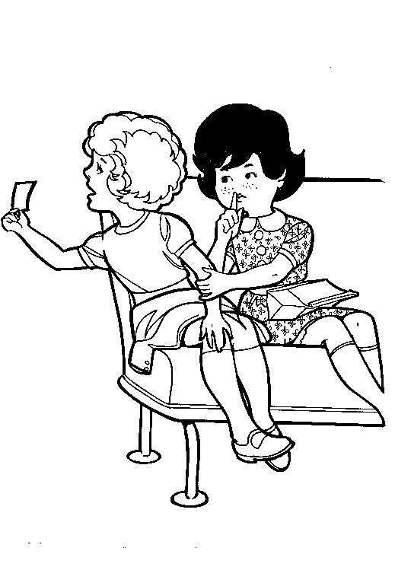Keep the Aisle Clear. DO NOT put personal items in aisle or in front of exits.
* Be courteous to fellow students and the school bus driver.

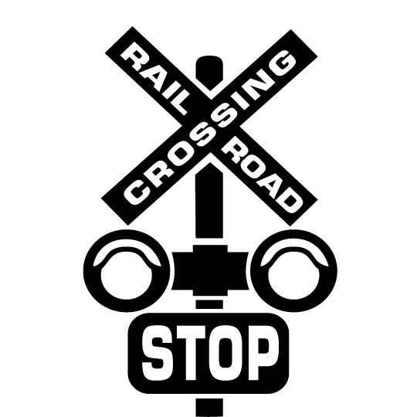**Rail Road Crossing**

* Remain silent (not just quiet) at all railroad crossings. The driver needs to look and listen for the train.

**Reporting Harassment**

* If you see other students being mistreated, tell the bus driver, teacher or principal

**GETTING OFF THE BUS**

**Prior to Your Stop**

* Gather personal items and remain seated until bus comes to a complete stop, but be prepared to exit promptly and safely.

**Use the Handrail.**

* Use the handrail to prevent slipping or falling.

**Cross in Front of the Bus.**

* LOOK both ways before stepping off the bus onto the street.
* Always cross the street in front where the bus driver can see you. Look for cars even though the stop sign is out.
* IF YOU DROP SOMETHING, tell the bus driver; Do not bend down to pick it up!!

**DANGER ZONE**

**Know the Danger Zone.**

* The most dangerous time of any bus trip is when you are OUTSIDE of the bus.
* The area within 10 feet around the bus is referred to as the DANGER ZONE. (This is 4 giant steps)
* Pay extra attention while your are in the DANGER ZONE.
* When you must cross the street, look carefully both ways. Cars do not always stop when they are supposed to.
* Remember, if you cannot see the driver’s eyes, the driver cannot see you. Tell the driver if you drop anything, and then wait for the driver to tell you what to do.
* 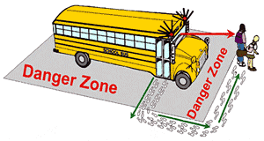 NEVER crawl under the school bus.

**EMERGENCIES**

**Remain Calm.**

* In an emergency it is up to you to stay calm. LISTEN to the bus driver and follow directions carefully the first time they are given.

**Know What to Do.**

* Learn where all the emergency exits are and how to open the door or window. Participate in emergency drills.

**Reporting Injury.**

* Tell the driver immediately if you are injured.
* Contacting Parents. Wait to contact parents until told to by the driver, teach or principal..

**BUS EVACUATION PROCEDURES**

**Know when to Evacuate.**

* Leave the bus only when the driver tells you to leave. Follow the driver’s instructions on which exits to use.
* Students are usually safer on the bus than outside the bus; however, certain situations – like some accidents or fire - may require that you leave the bus.

**Remain Calm.**

* Remain Seated until your turn to exit.
* Do not crowd the aisle. Leave personal items on the bus.
* Do NOT push. Secure loose clothing so it won’t get caught on the door or any other part of the bus.

**Move at a Brisk Pace but Carefully.**

* Duck your head and bend your knees if you must use the rear emergency door.

**Move away from the Bus.**

* Move away from the bus. Be aware of possible dangerous situations. Follow directions of driver and remain calm.
* Go to a safe location as directed by a bus driver, police or emergency workers