Instructions for 2022 – 2023 TDTIMS Submission
TDTIMS is due by Monday November 7, 2022.
This is a HARD DEADLINE for the 2022-2023 school year as this data needs to be incorporated for funding purposes in the current year. If not submitted on time, DPI will be contacting LEA Finance Officers the week of November 7th regarding the late TDTIMS submission and the potential financial impact.
Please PRINT and READ all instructions BEFORE doing anything.
After performing the TIMS data reviews and corrections outlined in the Preparing for 2022-2023 TDTIMS document, complete the steps below to submit TDTIMS. Please contact TIMS Support Staff at NCSU-ITRE or UNC Charlotte if you have any questions or need assistance in completing the TDTIMS.
TIMS Support Staff have already distributed the new Student Stop Distance Diagnostic to each LEA and have copied the Excel Workbook for 2022-2023 into your C:\tdtimsXLSxxx folder.

TDTIMS File Folder (C:\TDTIMS)
- On the C: Drive of the TIMS Server is a folder named TDTIMS.
- This is the folder where all reports will be created.
- Go inside the C:\TDTIMS folder and delete any and all files that exist.
- This folder must be empty to begin submitting TDTIMS.
tdtimsXLSxxx File Folder (C:\tdtimsxlsxxx)
- Inside the c:\tdtimsxls folder you will find the Excel Workbook for 2022-2023 TDTIMS
- After completing Steps #1 and #2 below, open the Excel Workbook and begin Step #3

Please contact TIMS Support Staff at NCSU or UNCC if you need help with any of the steps for TDTIMS.
Note: If you need to submit data from more than one dataset, such as SN data, you will first complete TDTIMS for the primary dataset (LIVE) and then create a new empty TDTIMS folder to begin again for the SN Dataset.
Steps to Complete and Submit TDTIMS
- ______ In EMU run:
Map Maintenance (to ensure all student distances are properly calculated)
And Batch\Process Run Directions*
Or LEAs may have a WEEKLY MAINTENANCE batch that contains both sets of EMU Utilities.

*You may also do this in Launchpad TIMS by going to Runs/Group Processes and completing the steps for BatchRun Directions. If you choose EMU, make sure the configuration treats existing directions in the appropriate manner for your district.

Review the positive and negative slack on each of your routes to ensure they are accurate. Positive slack may be correct but Negative slack should always be corrected. Contact your project leader if questions arise.

- ______ Run the following reports:

From the Edulog Reports Main Menu:

______Choose RR Crossing button. Perform the following steps outlined in red:

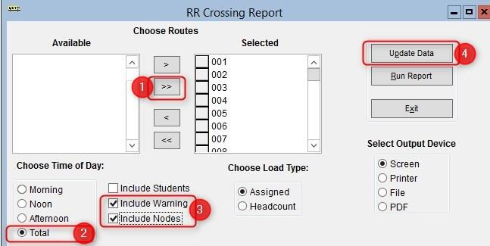
When ‘Done Processing’, exit back to the Reports Main Menu.

______ Create the Student Ride Times report.
Follow the steps below to generate the report

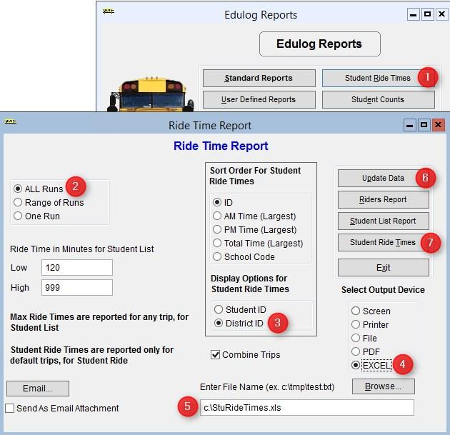

The numbers below correspond to the Red numbers in the diagram:
- From Reports Menu, select Student Ride Times button
- Choose All Runs
- Choose District ID under Display Options
- Choose Excel as the Output Device
- Enter the output path as C:\StuRideTimes.XLS (double check spelling!)
- Click Update Data
- Click Student Ride Times to create the report

Next, update the data and open the Riders Report via the following Steps
- From Reports Menu, select Student Ride Times button
- Choose All Runs
- Make sure Output Path is set to Screen
- Click Update Data
- Click Riders Report button to view the report
- Close the Print Preview of the Riders Report

______ From the User Defined Reports section, run the reports listed below:

Note: As you generate each report below, either print or write down the numbers from each as the information will be used to complete the 20222023 November.xls Excel Workbook.

Make sure each Workbook Report is set to Screen Output
______ All Students and Transportation > Workbook: Min/Max Stop/Bell Times
______ Stops, Runs Routes > Workbook: Route Count
______ Stops, Runs Routes > Workbook: Route Time and Miles
______ Bus Passes > Workbook: Count of Valid Riders
Completing the workbook:

Open the TDTIMS Workbook 20222023TDTIMS November.xls
- ______ Before you open the 20222023TDTIMSNovember.xls you may need to check the security level. To do this, open Excel, go to Tools/Macro/Security and set this to Medium.
* Enable Macros is Promoted. If using Excel 2007 you will need to click on the Office Button, then choose Excel Options, Trust Center, Trust Center Settings, Macro Settings and finally choose Enable all macros.
More recent versions of Excel may have you enable Macros in a different way, typically prompted to “Enable” in the yellow bar after opening the workbook each time. Contact your project Leader if you have any trouble enabling the workbook.
- ______ On the C: drive of your TIMS SERVER you will find a folder named TDTIMSXLSxxx
(where xxx is your LEA number). Inside this folder is the workbook named
20222023TDTIMS November.xls
Open this file and when prompted, click on Enable Macros or Enable Content.

- ______ On the Sign in page fill in all information requested, making sure to use proper names for
the Superintendent, Transportation Director and TIMS Coordinator as these will appear in the official audit letters. Use Drop down selections when applicable. Click the Continue to LEA info button when finished.

- ______ The next three pages consist of general questions about your LEA. If the answer is none,
enter a zero (0) instead of leaving blank. When you have completed a page click the Continue button at the bottom to proceed to the next page.
At the bottom of the LEA Info 3 page you will click the Continue to Data Input button.

- ______ To complete the Data Input page, reference the workbook reports printed before step 3.
They contain the information needed to complete the TIMS Data section of this workbook.
Important notes about completing the Data Input page:
• Use X:XX format (ie: 7:30) when entering earliest and latest bell/pickup times. Make sure you choose AM/PM from the drop down box where indicated.
• Non-Driving Time should be in minutes per day per bus, NOT a total time for all your buses.
• Complete the DPI Data section using information from the TD2 and TD2R your Director Submitted.

- ______ Review your percentages (%) at the bottom of the page and . . . (choose a or b below)

  - If satisfied with the results, click on the following buttons in this order:
      - Preview Audit. (Be Sure to PRINT the Audit Sheet)
      - Write TDTIMS Data File and Save Workbook
      - Save and Exit.
      - Review the printed Audit Sheet and Sign it.

  - If not satisfied with the results, then . . .
      - Click on the Save and Exit button.
      - Evaluate and make any corrections in Edulog that may improve your data.
      - Repeat steps 2 – 6 of these instructions.
      - Reopen your workbook, and edit or Clear All Data Fields then re-enter the information asked for under step 8.

- ______ Operators will manually generate each TDTIMS report listed below. All reports are located
in the User Defined Reports section: Simply select each report and click the Run Report
button.
No need to view the report if prompted. When selecting each report, make sure they are set to Disk File Output and there is a valid report path shown at the bottom of the reports menu (C:\TDTIMS\XXXXXXX)
______ Schools > -TDTIMS: Boundaries Archive
______ Schools > -TDTIMS: Clusters Archive* most LEAs will have no results.
______ Schools > -TDTIMS: Schools Archive

______ All Students and Transportation > Duke Report
______ All Students and Transportation > TDTIMS: Min/Max for Submission

______ Stops, Runs Routes > TDTIMS: AM ARRIVAL ARCHIVE
______ Stops, Runs Routes > TDTIMS: PM School Services Archive
______ Stops, Runs Routes > TDTIMS: Route Count
______ Stops, Runs Routes > TDTIMS: Route Time and Miles Submit
______ Stops, Runs Routes > TDTIMS: Runs and Routes Archive
______ Stops, Runs Routes > TDTIMS: Services and Stops Archive

______ Bus Passes > TDTIMS: ALL STUDENTS ARCHIVE
______ Bus Passes > TDTIMS: All Rider Distances
______ Bus Passes > TDTIMS: Count of Valid Riders
______ Bus Passes > TDTIMS: RIDERS ARCHIVE
______ Bus Passes > TDTIMS: Student Archive
______ Bus Passes > TDTIMS: Student Transportation Archive

THIS COMPLETES THE CREATION OF ALL TDTIMS REPORTS.

PLEASE FOLLOW THE STEPS ON THE NEXT PAGE TO COMPLETE THE TDTIMS SUBMISSION.

Running the ‘TDTIMS Processor’ and submitting Audit for review
11. ______ From the TIMS server, browse to C: drive and run TDTIMS ProcessorSQL v2022-2023.vbs
Right-Click Run as Administrator
Note: if you intend to submit TDTIMS for an alternate database (such as SN), then you
Will need to re-run the TDTIMS Processor as part of the steps for that database as well.

12. ______ If successful, the program will create a folder containing the files you need to submit. Example folders might look like: C:\TDTIMS2223_xxx or C:\TDTIMS2223_xxxSN

Before you submit your reports, PLEASE check the numbers on the Audit Sheet for accuracy.

Now you are ready to backup data and submit your audit:

______ Use ‘Launch ESM’ and make an archival backup of the database being submitted for
TDTIMS audit. In the description field, label the backup as ‘TDTIMS 2223 submission’
______ Sign the audit sheet and then Scan\Email a copy to your TIMS Project Leader.
We now prefer Scanned\Emailed copies of the Signed Audit Sheet but will accept a Faxed
version as well. Please contact TIMS Project Leaders if you wish to Fax the Audit Sheet.

______ TIMS Support Staff will send the Signed Audit Sheet to Kevin Harrison. No need to mail a signed copy to DPI for 2022-2023 TDTIMS.

______ In the past, you would transfer your data to UNCC via Coreftp. As that option no longer
exists, notify your project leaders (via email) when finished and they will collect the data
from your server.

TIMS Project Leaders would like to check your data as soon as possible to ensure all is correct and present within the TDTIMS Folders. Please do not move forward with normal route updates and changes after TDTIMS until your Project Leader has had a chance to review the reports and verify that all is correct. This will prevent us from having to restore data to rerun a report or file that may have been missed. Once the Project Leader gives you the “All Clear”, your TDTIMS submission will be complete and you can proceed with normal everyday routing updates.

