Instructions for 2019 – 2020 TDTIMS-NT Submission
Due date: on or before November 15th

Please PRINT and READ all instructions BEFORE doing anything.

During the week of October 18th there will be a TDTIMSXLS folder placed on the C:\ drive on your TIMS server. In this folder you will find the TDTIMS Excel workbook – named 20192020TDTIMS November.xls.

If you need to submit data from a second dataset, for example SN, you will need to complete steps 2-3 for that dataset as well.

1.
Visit www.ncbussafety.org/tims/qrg.html to download the document “Preparing for 2019_2020 TDTIMS if needed for tips and reports to run to diagnose data issues before submission. This document is outlines the steps for preprocessing and submission instructions.

2.
In EMU run:
i. Rebuild all Keys
ii. Build Route Directions*
iii. Dumpall

*You may do this in Edulog by going to ‘Routes/Group Processes’ or from EMU by running BATCHRTEDIR. If you choose EMU, make sure the configuration treats existing directions in the appropriate manner for your district. Review the positive and negative slack on each of your routes to ensure they are accurate. Positive slack may be correct but Negative slack should always be corrected.

3.
Run the following reports (which will be installed for you the week of October 18th):

Under Edulog Reports: (main menu):

_ Create the Student Ride Times Excel Spreadsheet
See instruction sheet on page 4 for Instructions

_ Choose RR Crossing button. Perform the following steps.

i. Select all routes by clicking the button with the double arrowheads pointing to the right.
ii. Choose Time of Day = Total iii. Choose Include Warning
iv. Choose Include Nodes v. Choose Assigned
vi. Click Update Data
vii. When you see ‘Done Processing. Press a key to continue’ then exit.

Under User Defined Reports:
(Be sure to print each report or write down the numbers from each report below as the information will be used to complete the 2019-2020 TDTIMS November.xls Workbook)

_ All Students and Transportation > Workbook: Min/Max Stop/Bell Times

_ Stops, Runs Routes > Workbook: Route Count

_ Stops, Runs Routes > Workbook: Route Time and Miles

_ Bus Passes > Workbook: Count of Valid Riders

Page 1

Complete the workbook:

You must have EXCEL version 2002 or newer to open 20192020TDTIMSNovember.xls

4.
Before you open the 20192020TDTIMSNovember.xls you need to check the security level of Excel. To do this, open Excel, go to Tools/Macro/Security and set this to Medium.
*If using Excel 2007 you will need to click on the Office Button, then choose Excel Options, Trust Center, Trust Center Settings, Macro Settings and finally choose Enable all macros.

More recent versions of Excel may have you enable Macros in a different way. Contact your project leader if you have any trouble enabling the workbook.

5.
On the C: drive of your computer you will find a folder named TDTIMSXLSxxx
(where xxx is your LEA number) Inside this folder you will find the excel spreadsheet named 20192020TDTIMSNovember.xls. Open this file and when prompted, click on Enable macros or Enable Content.

6.
On the Sign in page fill in all information requested, making sure to use proper names for the Superintendent, Transportation Director and TIMS Coordinator as these will appear in official letters. Click the Continue to LEA info button when finished.

7.
The next three pages consist of general questions about your LEA. When you have completed a page click the Continue button at the bottom to proceed to the next page. At the bottom of the LEA Info on page3 you will click the Continue to Data Input button.

8.
Complete the Data Input page. In step 3 you printed/reviewed four reports. They contain the information needed to complete the TIMS Data section of this workbook.

Important notes about completing the Data Input page:

• Use X:XX format (ie: 7:30) when entering earliest and latest bell/pickup times. Make sure you choose AM/PM from the drop down box where indicated.
• Non-Driving Time should be in minutes per day per bus, NOT a total time for all your buses.
• Complete the DPI Data section using information from your TD2 and TD2R.

9.
Review your percentages (%) at the bottom of the page and:

i. If satisfied with the results
A. Click on the following buttons in this order:
1. Preview Audit
i. Be Sure to Print the Audit Sheet
2. Write TDTIMS Data File and Save W orkbook
3. Save and Exit.
B. Review the printed Audit Sheet and Sign it.
ii. If not satisfied with the results
A. Click on the Save and Exit button.
B. Evaluate and make any corrections in Edulog that may improve your data.
C. Repeat steps 2 – 6 of these instructions.
D. Reopen your workbook, click on Clear All Data Fields, if you want button and reenter the information asked for under step 8.
Page 2

DO NOT PROCEED WITH THE FOLLOWING UNTIL STEPS 1-9
HAVE BEEN COMPLETED.

Running the ‘TDTIMS Processor’ and submitting Audit for review

10. At the root of the C:Drive, Run the program ‘TDTIMS processor NT v2019-2020’

Note: if you intend to submit TDTIMS for an alternate database (such as SN), then you will need to re-run the TDTIMS processor NT v2019-2020 for that database as well.

11. If successful, the program will create a folder containing the files you need to submit.
Example folder might be: C:\TDTIMS1920_xxx (where xxx is your LEA #)
If you have a SN database: C:\TDTIMS1920_xxxSN (where xxx is your LEA#)

Before you submit your reports, PLEASE check the numbers on the Audit Sheet for accuracy.

When you are ready to submit your reports – on or before November 15, 2019:

_ Sign and Scan/Email or Fax the audit sheet to your Project Leader (ITRE: 919-515-
7924 or UNCC: 704-687-5327)

_ Mail the original, signed audit sheet to Kevin Harrison, 6319 Mail Service Center, Raleigh, NC 27699-6319

_ In the past, you would transfer your data to UNCC via Coreftp. As that option no longer exists, notify your project leaders (via email) when finished and they will collect the data from your server.

_ TIMS Project Leaders would like to check your data as soon as possible to ensure all is correct and present within the folder you uploaded. Please do not move forward with normal route updates and changes after TDTIMS until your Project Leader has had a chance to review and verify that all is correct. This will prevent us from having to restore data to rerun a report or file that may have been missed.

_ Once your Project Leader gives you the “All Clear”, your TDTIMS Submission will be complete and you can proceed with normal everyday route updates.

Page 3

Processing the 2019-2020 TDTIMS Student Ride Times Report

Follow the steps listed below to generate the Student Ride Times Report in Excel format

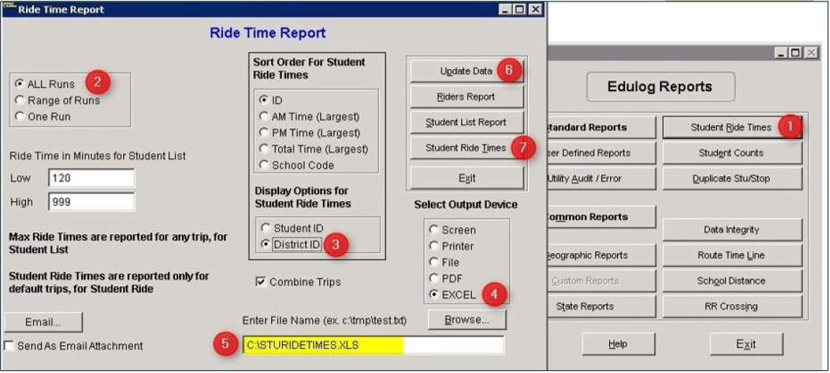

- From Reports Menu, select Student Ride Times (see 1 above)
- Choose All Runs (see 2 above)
- Choose District ID Under Display Options (see 3 above)
- Choose Excel as the Output Device (see 4 above)
- Enter the following path where the Excel fil will be created (see 5 above) or insure it is C:\STURIDETIMES.XLS
- Click Update Date (see 6 above)
- Click Student Ride Times to create the report in Excel format (see 7 above)

Page 4

