Instructions for 2019 – 2020 TDTIMS SQL Submission
Due: on or before November 15th
Please PRINT and READ all instructions BEFORE doing anything.
Project Leaders have placed a TDTIMSXLSxxx (xxx is your lea #) folder on the C:\ drive of your TIMS server. In this folder you will find the TDTIMS Excel workbook – named: 20192020TDTIMS November.xls
Note: If you need to submit data from a second dataset, for example SN, you will need to replicate steps 2-3 and 9-10 for that database as well.
- ______ Visit www.ncbussafety.org/tims/qrg.html and download the document “Preparing for
2019_2020 TDTIMS SQL”. This document contains a list of diagnose reports that may
help identify issues before submitting TDTIMS. This document outlines the steps for
pre-processing submission instructions.

- ______ In EMU run: 02. WEEKLY MAINTENANCE* this will update your run directions.

*You may also do this in Edulog by going to ‘Runs/Group Processes’ or from EMU using BatchRTE or BatchRun Directions. If you choose EMU, make sure the configuration treats existing directions in the appropriate manner for your district. SQL Sites with multi- tier routing should use Runs/Group Processes (instead of Routes/Group Processes) as this will allow the system to hold any manually edited arrival and departure times for Routes with multiple AM/PM Runs. Review the positive and negative slack on each of your routes to ensure they are accurate. Positive slack may be correct but Negative slack should always be corrected. Contact your project leader if questions arise.

- ______ Run the following reports:

From the Edulog Reports Main Menu:

______Choose RR Crossing button. Perform the following steps outlined in red:

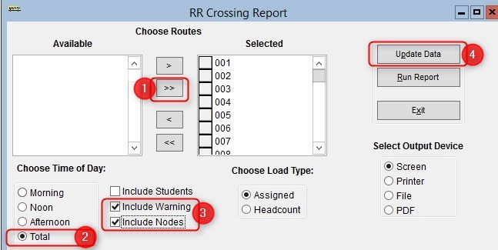
When ‘Done Processing’, exit back to the Reports Main Menu.

______ Create the Student Ride Times report.
Follow the steps below to generate the report

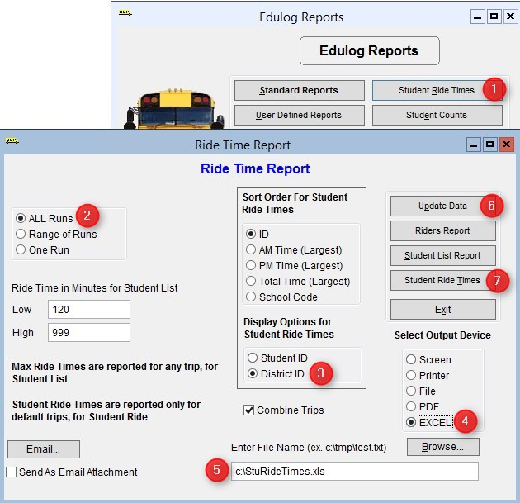

Numbers below correspond to the Red numbers in the diagram:

- From Reports Menu, select Student Ride Times button
- Choose All Runs
- Choose District ID under Display Options
- Choose Excel as the Output Device
- 5. Enter the output path as C:\StuRideTimes.XLS (double check spelling!)
- Click Update Data
- Click Student Ride Times to create the report

______ From the User Defined Reports section, run the reports listed below:

Note: As you generate each report below, either print or write down the numbers from each as the information will be used to complete the 2019-2020TDTIMS November.xls Excel Workbook.

______ All Students and Transportation > Workbook: Min/Max Stop/Bell Times
______ Stops, Runs Routes > Workbook: Route Count
______ Stops, Runs Routes > Workbook: Route Time and Miles
______ Bus Passes > Workbook: Count of Valid Riders

Completing the workbook:

You must have EXCEL version 2002 or newer to open 20192020TDTIMS November.xls
- ______ Before you open the 20192020TDTIMSNovember.xls you will need to check the security level. To do this, open Excel, go to Tools/Macro/Security and set this to Medium.
* If using Excel 2007 you will need to click on the Office Button, then choose Excel Options, Trust Center, Trust Center Settings, Macro Settings and finally choose Enable all macros.
More recent versions of Excel may have you enable Macros in a different way. Contact your project Leader if you have any trouble enabling the workbook.
- ______ On the C: drive of your TIMS SERVER you will find a folder named TDTIMSXLSxxx
(where xxx is your LEA number). Inside this folder is the workbook named
20192020TDTIMS November.xls Open this file and when prompted, click on Enable macros
or Enable Content.

- ______ On the Sign in page fill in all information requested, making sure to use proper names for
the Superintendent, Transportation Director and Coordinators as these will appear in the
official audit letters. Use Drop down selections when applicable. Click the Continue to LEA
info button when finished.

- ______ The next three pages consist of general questions about your LEA. If the answer is none,
enter a zero instead of leaving blank. When you have completed a page click the Continue
button at the bottom to proceed to the next page. At the bottom of the LEA Info 3 page
you will click the Continue to Data Input button.

- ______ To complete the Data Input page, reference the workbook reports printed from step 3.
They contain the information needed to complete the TIMS Data section of this workbook.
Important notes about completing the Data Input page:
• Use X:XX format (ie: 7:30) when entering earliest and latest bell/pickup times. Make sure you choose AM/PM from the drop down box where indicated.
• Non-Driving Time should be in minutes per day per bus, NOT a total time for all your buses.
• Complete the DPI Data section using information from your TD2 and TD2R.

- ______ Review your percentages (%) at the bottom of the page and . . . (choose a or b below)

  - If satisfied with the results, click on the following buttons in this order:
      - Preview Audit. (Be Sure to PRINT the Audit Sheet)
      - Write TDTIMS Data File and Save Workbook
      - Save and Exit.
      - Review the printed Audit Sheet and Sign it.

  - If not satisfied with the results, then . . .
      - Click on the Save and Exit button.
      - Evaluate and make any corrections in Edulog that may improve your data.
      - Repeat steps 2 – 6 of these instructions.
      - Reopen your workbook, and edit or Clear All Data Fields then re-enter the information asked for under step 8.

- ______ Operators will manually generate each TDTIMS report listed below. All reports are located
in the User Defined Reports section: Simply select each report and click the Run Report
button. No need to view if prompted.
______ Schools > -TDTIMS: Boundaries Archive [12.4]
______ Schools > -TDTIMS: Clusters Archive [12.4] *most LEAs will have no results.
______ Schools > -TDTIMS: Schools Archive [12.4]

______ All Students and Transportation > Duke Report [12.4]
______ All Students and Transportation > TDTIMS: Min/Max for Submission [12.4]

______ Stops, Runs Routes > TDTIMS: AM ARRIVAL ARCHIVE [12.4]
______ Stops, Runs Routes > TDTIMS: PM School Services Archive [12.4]
______ Stops, Runs Routes > TDTIMS: Route Count [12.4]
______ Stops, Runs Routes > TDTIMS: Route Time and Miles Submit [12.4]
______ Stops, Runs Routes > TDTIMS: Runs and Routes Archive [12.4]
______ Stops, Runs Routes > TDTIMS: Services and Stops Archive [12.4]

______ Bus Passes > TDTIMS: ALL STUDENTS ARCHIVE [12.4]
______ Bus Passes > TDTIMS: All Rider Distances [12.4]
______ Bus Passes > TDTIMS: Count of Valid Riders [12.4]
______ Bus Passes > TDTIMS: RIDERS ARCHIVE [12.4]
______ Bus Passes > TDTIMS: Student Archive [12.4]
______ Bus Passes > TDTIMS: Student Transportation Archive [12.4]
Running the ‘TDTIMS Processor’ and submitting Audit for review
11. ______ From the TIMS server, browse to C: drive and run TDTIMS ProcessorSQL v2019-2020a.vbs

Note: if you intend to submit TDTIMS for an alternate database (such as SN), then you
Will need to re-run the TDTIMS processorSQL v2019-2020 for that database as well.

12. ______ If successful, the program will create a folder containing the files you need to submit. Example folders might look like: C:\TDTIMS1920_xxx or C:\TDTIMS1920_xxxSN

Before you submit your reports, PLEASE check the numbers on the Audit Sheet for accuracy.

Now you are ready to backup data and submit your audit:

______ Use ‘Launch ESM’ and make an archival backup of the database being submitted for
TDTIMS audit. In the description field, label the backup as ‘TDTIMS 1920 submission’
______ Sign and fax the audit sheet to your Project Leader at . . . .
ITRE: 919-515-7924 or UNCC: 704-687-5327

______ Mail the original, signed audit sheet to Kevin Harrison, 6319 Mail Service Center, Raleigh,
NC 27699-6319

______ In the past, you would transfer your data to UNCC via Coreftp. As that option no longer
exists, notify your project leaders (via email) when finished and they will collect the data
from your server.

TIMS Project Leaders would like to check your data as soon as possible to ensure all is correct and present within the folder you uploaded. Please do not move forward with normal route updates and changes after TDTIMS until your Project Leader has had a chance to review and verify that all is correct. This will prevent us from having to restore data to rerun a report or file that may have been missed. Once the Project Leader gives you the “All Clear”, your TDTIMS submission will be complete and you can proceed with normal everyday routing updates.

